
The following information should be provided by the applicant, as applicable. This is a fairly thorough checklist and not all items will be necessary for every application:

The minimum information to be provided is as follows:
- Name and address of applicant;
- Permit or reference number (if applicable);
- Property description; including street address, parish name, CA No, Section No, Lot No, LP or PS details;
- Purpose of application, eg dwelling, subdivision, earthworks;
- An accurate sketch showing location of proposal on property, eg dwelling, earthworks;
- An accurate locality plan of the property, showing existing property boundaries (and proposed subdivision boundaries if proposed); and
- A regional locality plan to determine the property’s whereabouts within the catchment.

The following additional information may be required where applicable:
- Existing and proposed use of the site;
- The number of people expected on site during normal operations;
- An accurate locality plan of the property
- existing natural surface levels, including levels at the proposed building site and along the access-way to the property boundary;
- existing and proposed buildings, including floor levels;
- existing and proposed earthworks, including finished surface levels, embankment alignments and crest levels;
- existing and proposed fencing;
- existing and proposed road or access-way alignments and crest levels;
- existing and proposed drainage systems, including waterways, pipelines, drains, culverts and bridges;
- other important physical features upstream and downstream of the property that may affect flows, such as levee banks, fences and retaining walls.

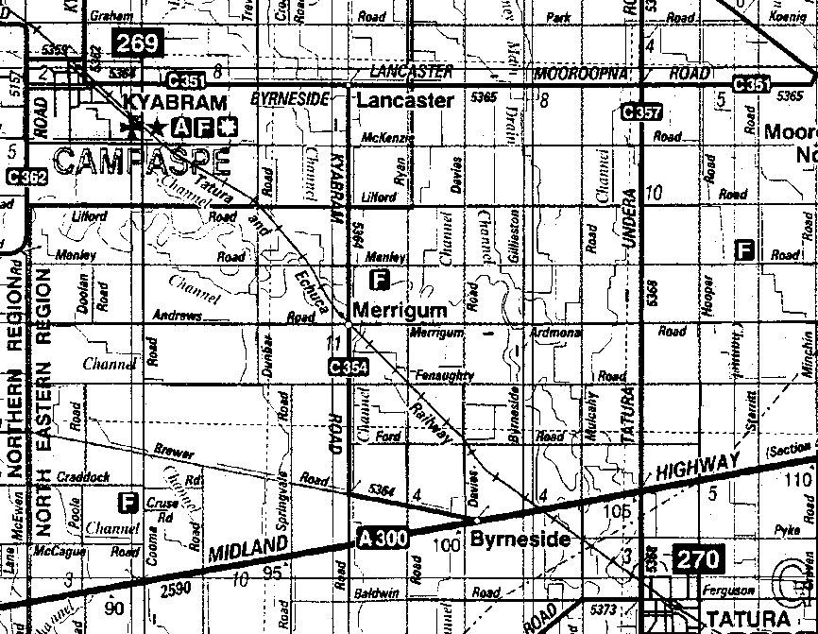
Property Location

Regional Locality Plan

Can be a copy of VicRoads Directory
or CFA map.

N

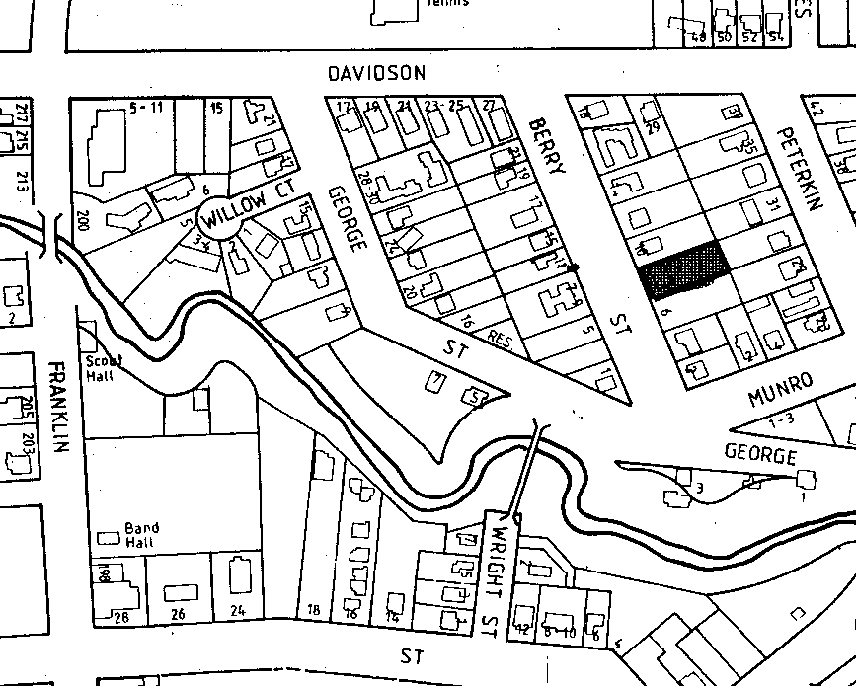

Locality Plan
Subject Property

This should show the property boundaries as
well as adjacent properties and several
identifiable roads.

N

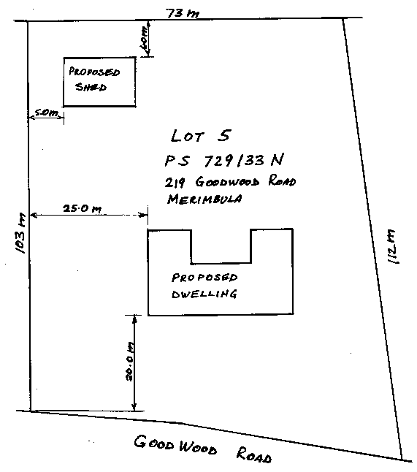

Sketch of Proposed Works

This should show a reasonably
accurate location of the proposed
works within the subject property.

N

